Database Assignment 1

Note : Use Emp, dept and salgrade table

1. To list all records with sal > 2000 and comm>200

Select * from emp Where sal > 2000 and comm >200;

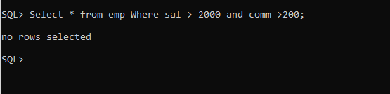

If sal > 1000 and comm>200

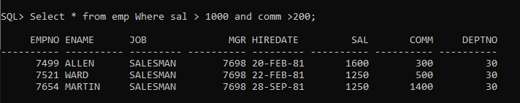

2. To list all record with job=’Clerk’ or sal>2000

Select * from emp where job=’CLERK’ or sal>2000;

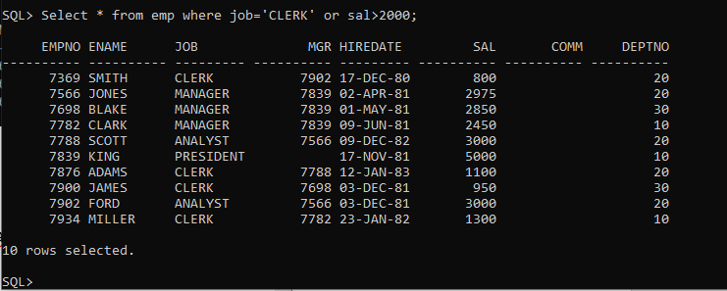

3. To list all the record with sal=1250 or 1100 or 2850

Select * from emp where sal in (1250,1100,2850);

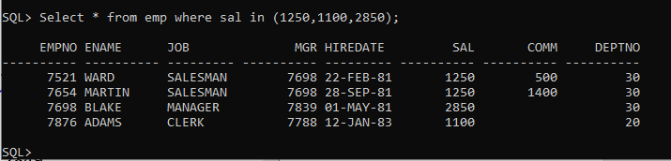

4. To list all employees with sal>1250 and <2850

Select * from emp where sal between 1251 and 2849;

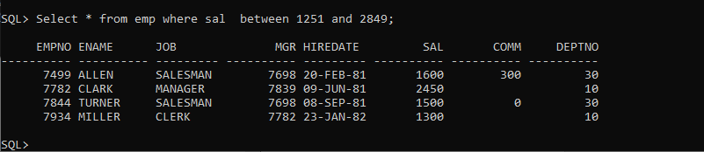

5. To list all employees with name ends with AS

Select * from emp where ename like ‘%AS’;



If name ends with only S;

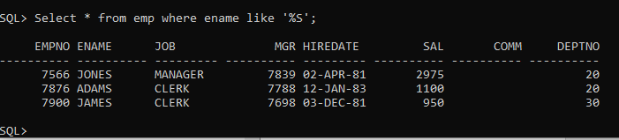

6. To list all employees with job starts with C and ends with K

Select * from emp where job like ‘C%K’;

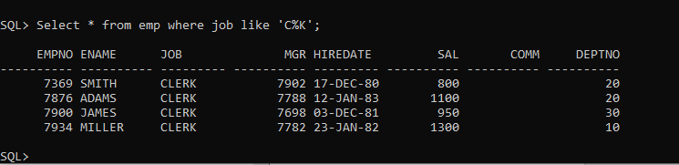

7. To list all employees with job contains L at third position and

M at third last position

Select * from emp where job like ‘__L%M__’;

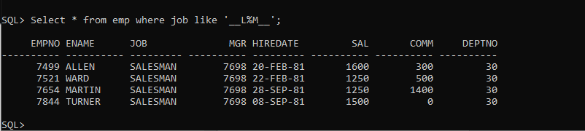

8. To list all the record with sal not equal to 1250 or 1100 or 2850

Select * from emp where sal not in (1250,1100,2850);

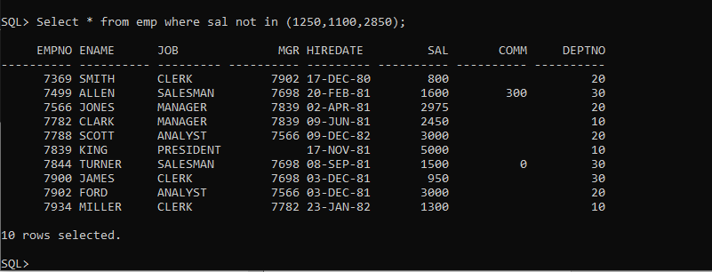

9. To list all employees with salnot >1250 and <2850

Select * from emp where sal not between 1251 and 2849;

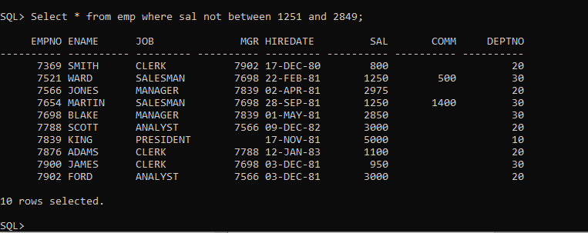

10. To list all employees with job starts with C , E at 3rd position and ends with K

Select * from emp where job like ‘C_E%K’;

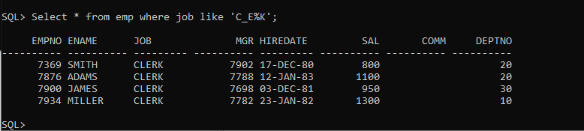

Select * from emp where REGEXP_LIKE(job,’^C.E.*K$’);

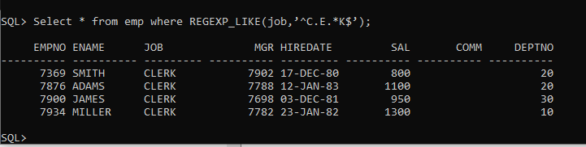

11. To list all rows with comm is null

Select * from emp where comm is null;

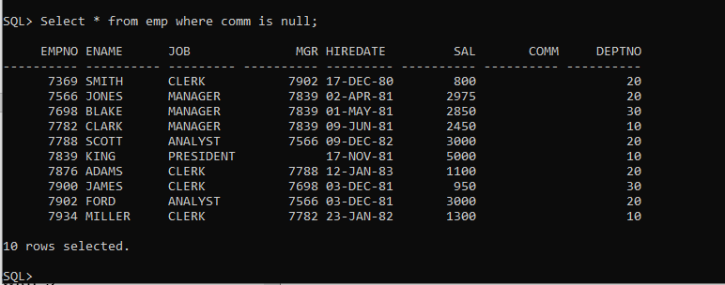

12. To list all employees with sal is null and name starts with ‘S’

Select * from emp where sal is null and ename like ‘S%’;

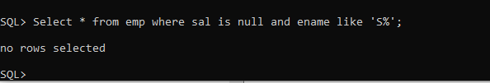

If comm is null

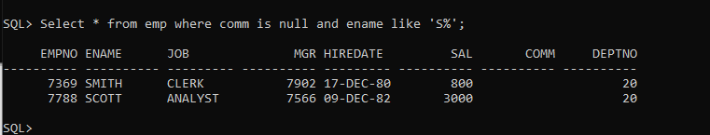

13. To list all employees with job contains 5 characters

Select * from emp where REGEXP_LIKE(job,’^…..$’);

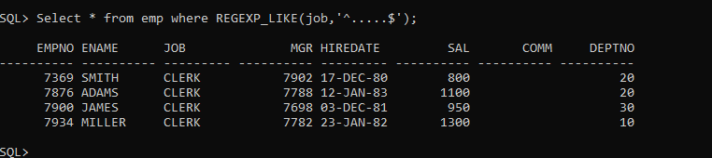

Select * from emp where REGEXP_LIKE(job,’^.{5}$’);

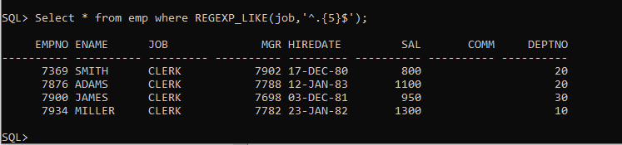

14. To list all employees with name contain ‘A’ at 1 position and job

Contains 5 characters

Select * from emp where REGEXP_LIKE(ename,’^A’) and REGEXP_LIKE(job,’^…..$’);

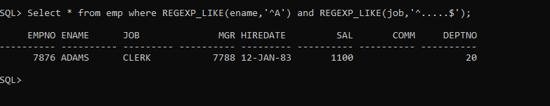

Q2. Solve the following

1. Retrieve the details (Name, Salary and dept no) of the emp who are working in

department code 20, 30 and 40.

Select ename,sal,deptno from emp where deptno in (20,30,40);

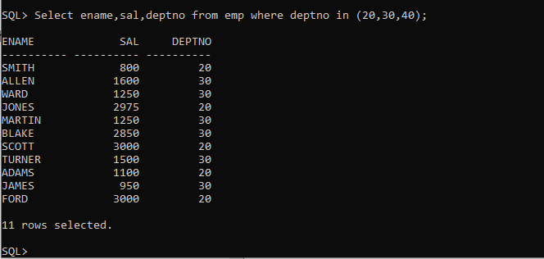

2. Display the total salary of all employees . Total salary will be calculated as

sal+comm+sal*0.10

select sal,nvl(comm,0) comm, sal + nvl(comm,0)+sal*0.1 net_sal from emp;

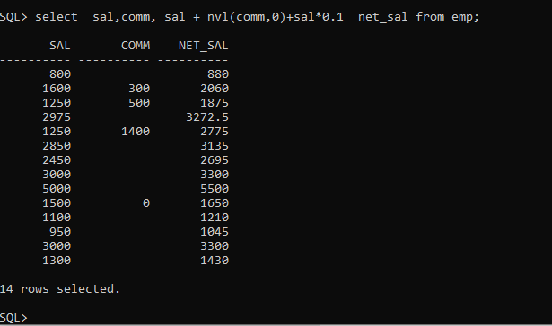

3. List the Name and job of the emp who have joined before 1 jan 1986 and whose

salary range is between 1200and 2500. Display the columns with user defined Column

headers.

Select * from emp where sal between 1200 and 2500 and hiredate<’1-jan-86’;

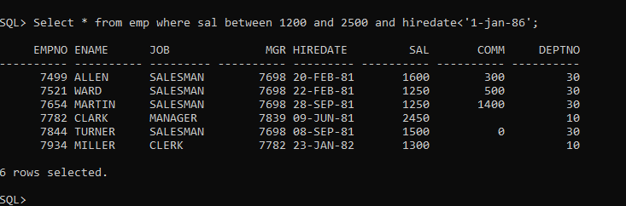

4. List the empno, name, and department number of the emp works under manager

with id 7698

select empno,ename,deptno from emp where mgr=7698;

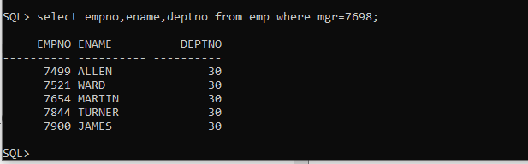

5. List the name, job, and salary of the emp who are working in departments 10 and

30.

Select ename,job,sal from emp where deptno in (10,30);

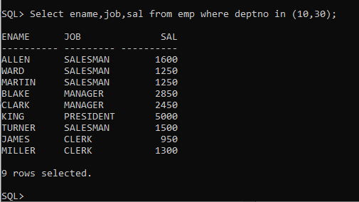

6. Display name concatenated with dept code separated by comma and space. Name

the column as ‘Emp info’.

Select ename,deptno, ename || ',' || ' ' ||deptno AS empinfo from emp;

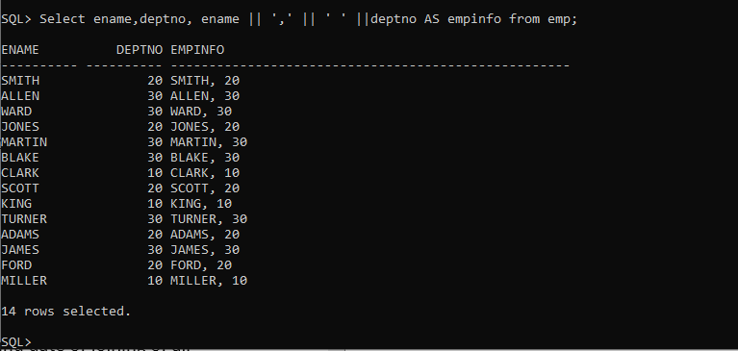

Select ename,deptno,concat(concat(concat(ename,’,’),’ ‘),deptno) AS empinfo from emp;

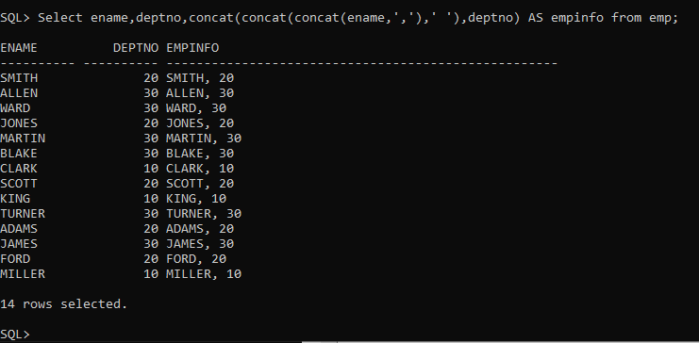

7. Display the emp details who do not have manager.

Select * from emp where mgr is null;

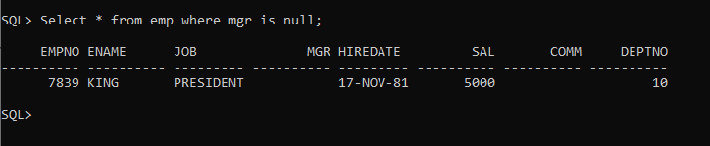

8. Write a query which will display name, department no and date of joining of all

employee who were joined January 1, 1981 and March 31, 1983. Sort it based on date of

joining (ascending).

Select ename,deptno,hiredate from emp where hiredate between ’01-jan-81’ and ‘31-mar-83’ order by hiredate;

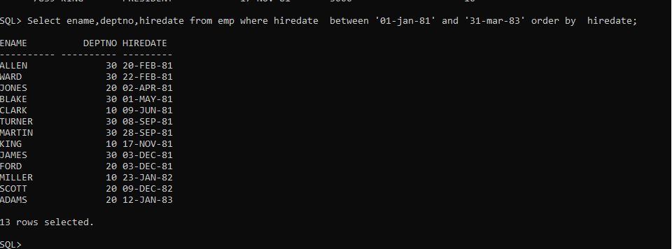

9. Display the employee details where the job contains word ‘AGE’ anywhere in the Job

Select * from emp where REGEXP_LIKE(job,’AGE*’);

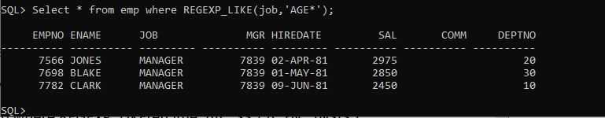

11. List the details of the employee , whose names start with ‘A’ and end with ‘S’ or

whose names contains N as the second or third character, and ending with either ‘N’ or ‘S’.

select * from emp where REGEXP_LIKE(ename,’^A.*S$|^..?N.*[NS]$’);

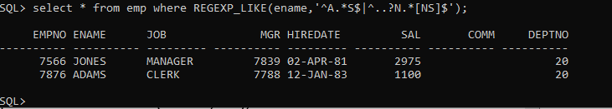

12. List the names of the emp having ‘_’ character in their name.

Select * from emp where REGEXP_LIKE(ename,’_+’);



Group functions

1. Display the Highest, Lowest, Total & Average salary of all employee. Label the columns

Maximum, Minimum, Total and Average respectively for each Department. Also round the

result to the nearest whole number.

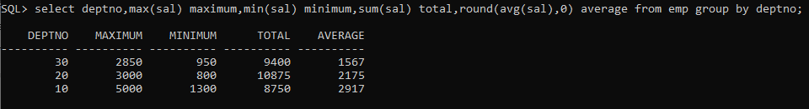

2. Display Department no and number of managers working in that department. Label the

column as ‘Total Number of Managers’ for each department.

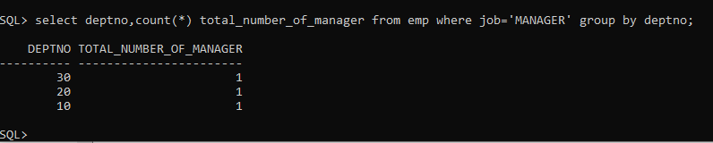

3. Get the Department number, and sum of Salary of all non managers where the sum is

greater than 20000.



If sum > 2000

